Storytelling jewelry

1-Somaya Wail Ismail:
Somaya is a jewelry designer, maker, and passionate advocate for craft based learning in design. She currently oversees the jewelry design workshop at the German International University. Drawing on her experience as a former engineer and her time at the Jameel House for Traditional Arts, Somaya combines technical insight with a deep appreciation for heritage craft. She designs and makes jewelry inspired by heritage, blending traditional influences with contemporary expression. In addition to her own practice, she leads practical jewelry workshops that reconnect participants with traditional techniques and nurture their creativity. Her teaching blends problem-solving skills with hands-on creative approaches, inspiring students to explore new possibilities in material, process, and collaboration. Through her classroom and workshop practice, Somaya continues to champion the power of making as a means to foster engagement, innovation, and a deeper connection to heritage.

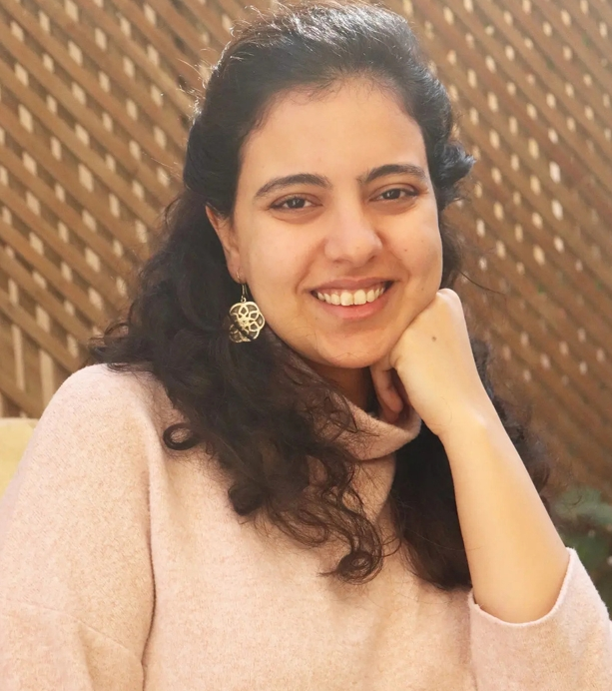

2- Heba El Naggar:
Colors, drawing and handcrafting things in arts and fashion were my favorite hobbies since childhood. Although I have graduated with a university degree in Law, I have shifted my personal and professional life into my childhood passion. My fruitful and enjoyable journey into jewellery started almost ten years ago, driven by the desire to create inspired and unique pieces to reveal the civilizations. In fact, the work of art has a philosophical dimension which I embed through my handcrafted jewellery and accessories to be able to convey particular meanings or to tell a story. I believe that I am a gifted handcrafted maker by nature which I have enriched through continuous studies; Jewellery designs, Metal hand engraving, Jewellery by Wax and Jewellery making with metal (gold, silver and brass). My technical studies have been an eye opener to deliver state-of-art collections and pieces.
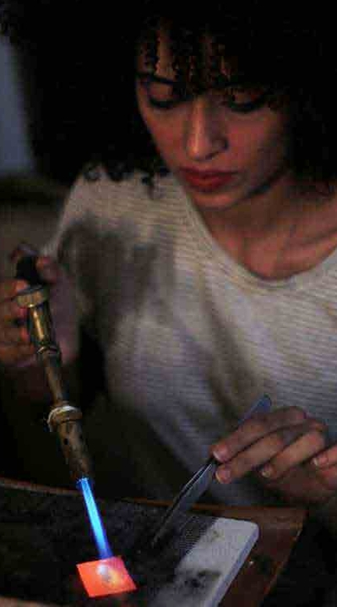

3-Heba Salloum:
I get inspiration from everything around me, every detail can spark a new design. I believe that beauty lies in simplicity, and I design with passion to turn ideas into pieces that reflect my artistic soul.
Seeing my creations come to life as pieces that capture attention and touch people’s hearts brings me joy. For me every design is a new journey that adds meaning and happiness to my creative path. 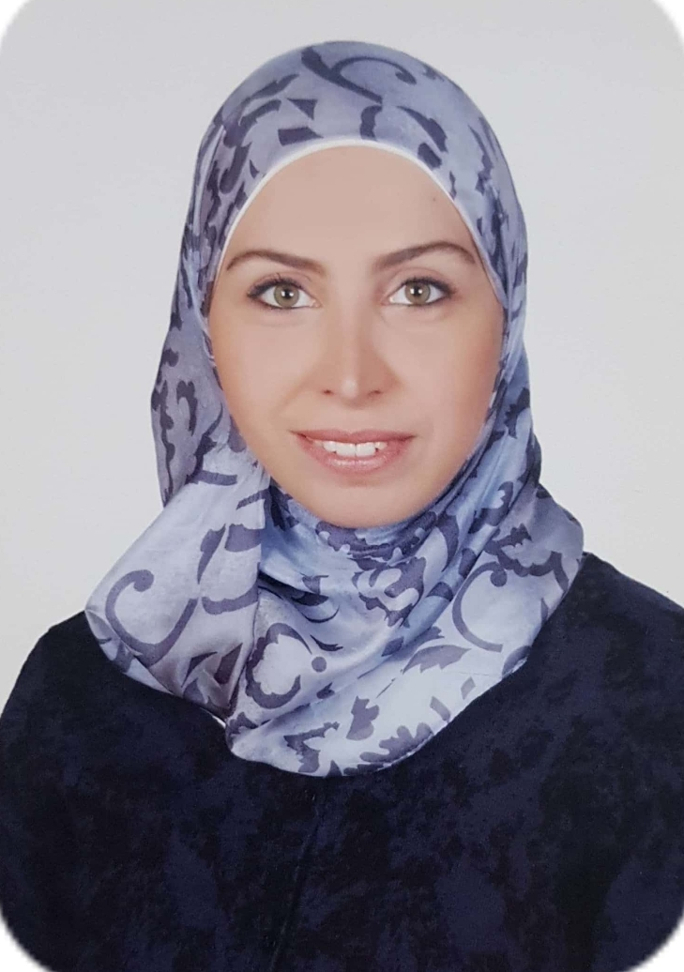

4-دينا عتمان:
Handmade jewelry artist
A student at the Beit Jameel School of Traditional Arts and Crafts
Studied at the Jewelry Making Center of the Egyptian Ministry of Industry
Studyed a diploma in contemporary Islamic art with the Mamlouk Foundation.
